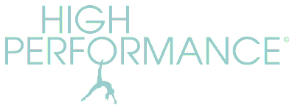http://www.highperformancepilates.co.uk Tel: 07973383103
MAY 2024 STUDIO COURSES AT SPRINGHEAD
Bookable in blocks. No partial bookings
Clients should provide their own mat and head cushion/towel. Small equipment is optional.
Missed classes can be made up with any Zoom or studio class in lieu, to be taken within a month of the missed class date. Classes are 55 mins long.

10.30am: Mon 13 May – Mon 20 May (2 weeks) - £18 (no class Mon 27 May Bank Holiday)
10.30am: Wed 15 May – Wed 29 May (3 weeks) - £27
PLEASE SCROLL TO BOTTOM TO SEE HOLIDAY DATES

1:1 & 2:1 STUDIO SESSIONS AT DOBCROSS
55min sessions available Mon – Thurs afternoons.
£45 per single session 1:1 or £200 for 5 sessions
£60 per single session 2:1 (two people sharing) or £250 for 5 sessions

ZOOM CLASSES
Online classes remain ‘Pay As You Go’ at £7.50 per class and are open to all clients.
WEDNESDAY 6.30pm
FRIDAY 10am
1:1 ZOOM SESSIONS
Available on request by arrangement and cost £35 per session (or £50 for 2:1)

MAY Pass: no May Pass available
HOLIDAYS:
I have a holiday booked (!) so there will be no Pilates Wed 24 April – Fri 10 May incl.
Also: No Pilates on Bank Holiday Monday 27 May

