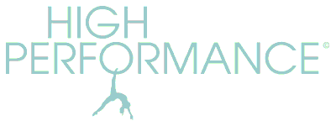http://www.highperformancepilates.co.uk Tel: 07973 383103
DECEMBER 2025 STUDIO COURSES
Bookable in blocks. No partial bookings. Clients should provide their own head cushion/towel. Small equipment and a mat are optional. Classes are 55 mins long.
Springhead 11am: Mon 01 Dec– Mon 22 Dec (4 weeks) - £40
Uppermill 8.55am: Tues 02 Dec – Tues 23 Dec (4 weeks) - £40
Uppermill 10am: no classes
Springhead 11am: Wed 03 Dec – Wed 17 Dec (3 weeks) - £30 *

*Please note that there will be no Pilates from Tues 06 Jan 2026 to Fri 06 Feb 2026 incl.
Additional Xmas and New Year Zoom classes below – just pay in the usual way and let me know which Zoom(s) you wish to attend and I will send you the link.

*Drop-in studio classes: (book up to 3 days in advance) available to existing clients only if there are spaces on the booked courses - £12.50 each. Email for details.

Missed classes can be made up with any Zoom or studio class in lieu, to be taken within a month of the missed class date.

1:1 & 2:1 STUDIO SESSIONS AT DOBCROSS
55min sessions available Mon – Thurs afternoons.
£50 per single session 1:1 or £220 for 5 sessions
£70 per single session 2:1 (two people sharing) or £300 for 5 sessions

ZOOM CLASSES
Online classes are ‘Pay As You Go’ at £8.50 per class and are open to all clients.
WEDNESDAYS 03, 10, 17 Dec 6.30pm
FRIDAYS 05, 12, 19 Dec 10am

EXTRA Zoom sessions in Dec/Jan at 10am:
Mon 29 Dec
Tues 30 Dec
Fri 02 Jan
Mon 05 Jan
Tues 06 Jan

1:1 ZOOM SESSIONS
Available on request by arrangement and cost £40 per session (or £60 for 2:1)

DECEMBER Pass: Book up to 10 classes (studio and Zoom) during the December/January block for £75.00. Cannot be used for 1:1 sessions.

