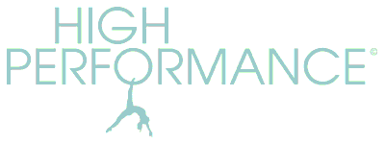http://www.highperformancepilates.co.uk Tel: 07973 383103
MARCH 2026 STUDIO COURSES
Bookable in blocks. No partial bookings. Clients should provide their own head cushion/towel. Small equipment and a mat are optional. Classes are 55 mins long.
Springhead 11am: Mon 02 Mar – Mon 23 Mar (4 weeks) - £40
Uppermill 8.55am: Tues 03 Mar – Tues 24 Mar (4 weeks) - £40
Uppermill 10am: Tues 03 Mar – Tues 24 Mar (4 weeks) - £40
Springhead 11am: Wed 04 Mar – Wed 25 Mar (4 weeks) - £40

*Drop-in studio classes: (book up to 3 days in advance) available to existing clients only if there are spaces on the booked courses - £12.50 each. Email for details.

Missed classes can be made up with any Zoom or studio class in lieu, to be taken within a month of the missed class date.

1:1 & 2:1 STUDIO SESSIONS AT DOBCROSS
55min sessions available Mon – Thurs afternoons.
£50 per single session 1:1 or £220 for 5 sessions
£70 per single session 2:1 (two people sharing) or £300 for 5 sessions

ZOOM CLASSES
Online classes are ‘Pay As You Go’ at £8.50 per class and are open to all clients.
WEDNESDAY 6.30pm
FRIDAY 10am
1:1 ZOOM SESSIONS
Available on request by arrangement and cost £40 per session (or £60 for 2:1)

MARCH Pass: Book up to 10 classes (studio and Zoom) during the March block for £75.00. Cannot be used for 1:1 sessions.

